2026 Department Convention
Lunch and American Legion Family Joint Banquet Tickets

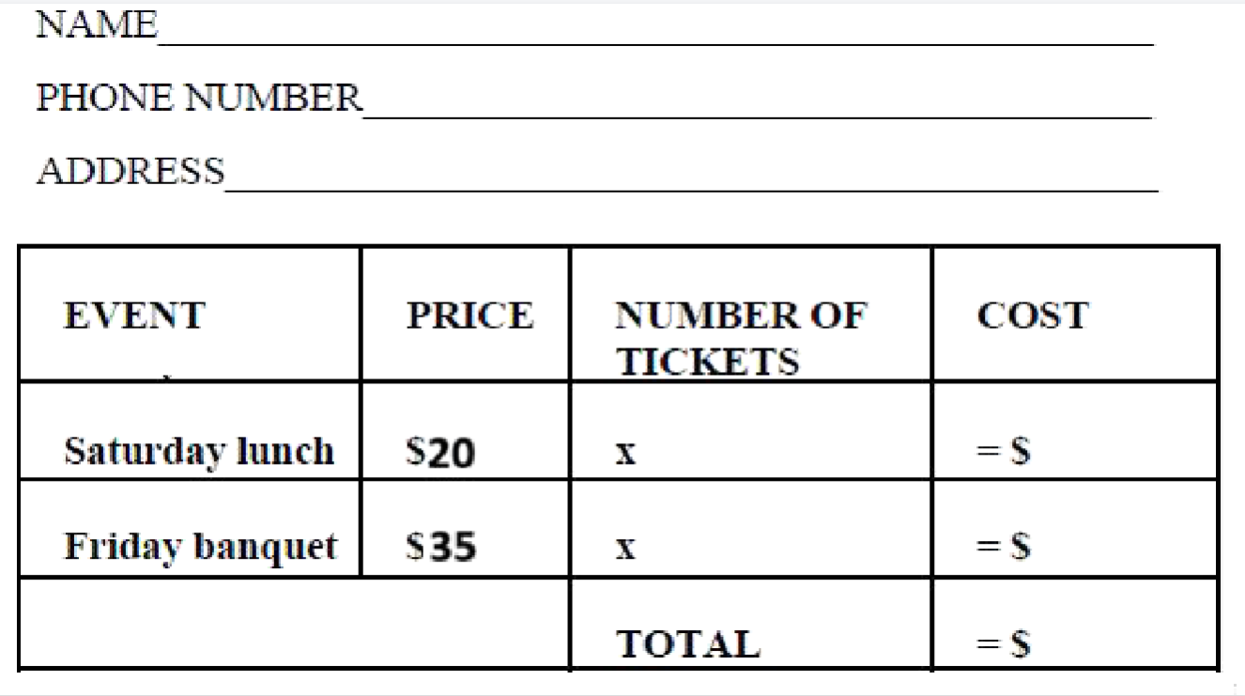
Friday, June 19th American Legion Family Banquet, $35/person-Roast Beef, house salad, chef’s choice of starch, vegetable, house bread
Saturday, June 20th, Deli lunch, $20/person
Tickets requests for all members must be received no later than May 26th, 2026. NO TICKETS WILL BE SOLD AT THE EVENT. Tickets can be picked up at the conference registration table. One check can be made for the total lunch and joint banquet ticket costs. Please make checks payable to Sidney L Smith Post 24. Ticket requests must be received by May 29th, 2026 to:
Sidney L Smith Post 24
PO Box 2052
Aberdeen SD 57402
NO TICKETS WILL BE SOLD AT THE EVENT

