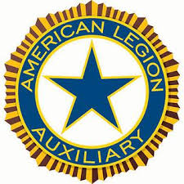
2026 American Legion Auxiliary Banquet
Honoring Past Department President Shirley Baker

Saturday evening, June 20th, 2026, we will be hosting an American Legion Auxiliary Banquet honoring our 25th Anniversary Past Department President Shirley Baker. A Montreal bacon wrapped pork chop, with mushroom demi-glace, house garden salad, chef’s choice of starch, vegetable, house bread & butter will be served. The meal will be $35/person. There will be a social party at 5:30 with dinner served at 6:00 pm.
Name_______________________________________________________________
Address_____________________________________________________________
City, State, Zip Code__________________________________________________
Phone Number_______________________________________________________
Any dietary restrictions________________________________________________
Ticket requests for the Auxiliary Banquet must be received no later than May 15th, 2026. NO TICKETS WILL BE SOLD AT THE EVENT. Tickets can be picked up at the conference registration table. Please make check payable to: SD ALA
Ticket requests should be sent to:
SD American Legion Auxiliary Department Headquarters
PO Box 983
Mitchell, SD 57301

Auxiliary Banquet | Number of Tickets | x $35.00 | Total Cost

