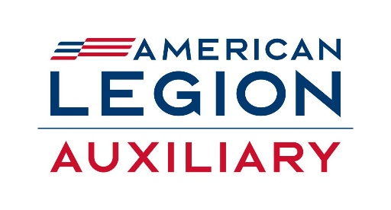
2024-2025 SD ALA Legislative Chairman: Micheline Nelson
Email: Micheline.nelson@live.com
Phone: 605-645-1346
2025-2026 SD ALA Legislative Committee: Kathy Evenson and The SD American Legion Legislative Committee

Get Involved
Purpose: The purpose of the Legislative Committee is to provide information and assistance to American Legion Auxiliary members to advocate for the legislative agenda of The American Legion. Standing Rule #5, National Committees – Mission Outreach
- Utilize The American Legion’s Legislative Website at www.legion.org/legislativeto obtain information on legislative priorities, call for immediate action, and connect with representatives.
  - Grassroots Action Center
  - Sign up for alerts.
  - Locate pending legislation.
  - Contact your representatives.
  - Report on meetings with representatives.
- Host a Meet the Candidates Night. Invite all candidates involved in a specific election for a question-and-answer session, not a debate with a townhall format with no Legion Family signage.
https://member.legion-aux.org/Member/Committees/Legislative/How-to-Host-a-Meet-the-Candidate-Night
- Promote the ALA Legislative Advocacy Guide to develop a plan to increase legislative awareness in your community. https://member.legion-aux.org/Member/Guides/Advocacy-Guide
- Join the Legislative Mini-Council to advocate for The American Legion Family’s legislative priorities with members of Congress with whom you have personal relationships.
- Stay on top of upcoming legislative initiatives that may impact the efforts of Be the One and mental health awareness https://www.legion.org/betheone
Nonpolitical Etiquette
ALA C&BL - Article II Section 1. The American Legion Auxiliary is a civilian patriotic service organization that supports the mission of The American Legion. Section 2. The American Legion Auxiliary shall be absolutely nonpolitical and shall not be used for the dissemination of partisan principles nor for any promotion of the candidacy of any person seeking public office or preferment.

- The ALA Legislative Committee is requesting that each ALA member respects the ALA nonpolitical status by avoiding posting pictures of any candidates when wearing the ALA brand logo, on any social media platforms. It could be misinterpreted as taking a political position.
- The ALA Legislative Committee is also requesting to avoid political comments in person or on social media when wearing the ALA brand logo.

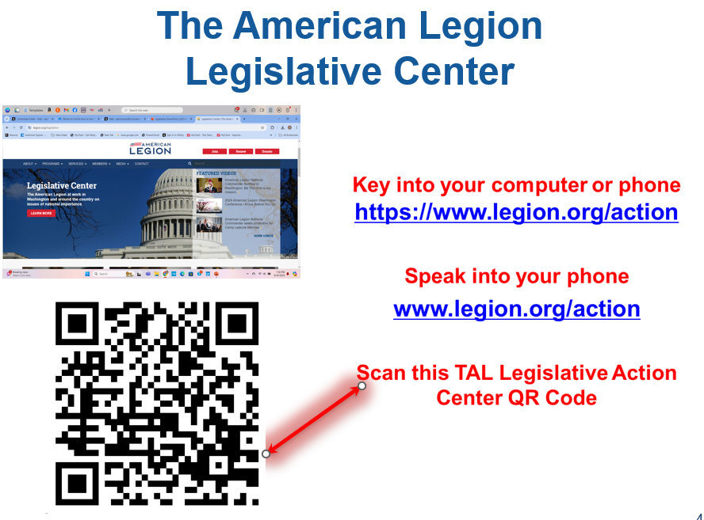
How to Complete your Report and Awards
Key Program Statement:
The Legislative program provides information and assistance to American Legion Auxiliary members to advocate for the legislative agenda of The American Legion. Legislative Committee (legion-aux.org)

As part of your narrative report, please include answers to the following questions:
- How did your unit promote the legislative agenda of The American Legion? What training or information did your unit use to inform members of legislative priorities and the Grassroots Action Center on The American Legion’s legislative website?
- What course of action did members or unit use to advocate for The American Legion’s legislative agenda?
- What legislative activities (town hall meetings, legislative receptions) did members attend and host in their communities? What suggestions did members have to improve those activities?
- What avenues did members use to develop relationships with elected officials? Did members serve on the Legislative Council?
- Please describe how members connected with their local, state, and national officials and their successes. How many members received a response from their officials and in what format?
- These should be tied directly to the Program Engagement Plan (where applicable) or the Key Program Statements.

Due Dates
After an event, you may complete a narrative and email it to Micheline.nelson@live.com and ALA president

April 15, 2026: Unit submit their written narrative report (answer as many questions as possible) and attach pictures. Preferably by email to micheline.nelson@live.com
Or mail to Micheline Nelson, 19650 Mossing Lane, Spearfish – SD 57783

May 1, 2026: SD ALA Chairman submits the department report to the Northwestern Division Chairman

June 1, 2025: Deadline to apply for the Unit Program Award or Department Program Award – online form on the National ALA website.

