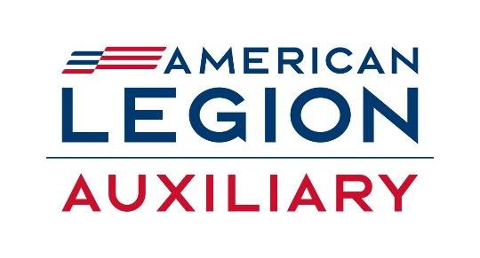
2025 Department of South Dakota Membership
“There’s No Place Like Being a Member”
9279
Department membership goals were based on each department’s 2023 membership as of 30 days prior to the 2023 national convention PLUS the percentage increase determined by your department leadership at the 2024 Department Leadership National Conference.
National incentives:
Recruit/Rejoin 10 members – Fill out application on department web page, send into National Office and the member will receive a gift from the National Membership Committee.

Department Award: 75% Award
• Award: $75 to be used to advance the ALA mission
• Presented to: Departments reaching 75% of their 2025 department membership goal.
• Deadline: Pearl Harbor Day, December 7, 2024.
• Materials and guidelines: Award will be based on membership entered in the ALAMIS member database by December 7, 2024.
Department Award: 85% Award
• Award: $85 to be used to advance the ALA mission
• Presented to: Departments reaching 85% of their 2025 department membership goal.
• Deadline: TAL Birthday, March 15, 2025.
• Materials and guidelines: Award will be based on membership entered in the ALAMIS member database by March 15, 2025.
Department Award: 95% Award
• Award: $95 to be used to advance the ALA mission
• Presented to: Departments reaching 95% of their 2025 department membership goal.
• Deadline: National Poppy Day®, May 23, 2025.
• Materials and guidelines: Award will be based on membership entered in the ALAMIS member database by May 23, 2025. Department Award: 100% Award
• Award: $250 to be used to advance the ALA mission
• Presented to: Any department that has reached 100% of their department goal.
• Deadline: Independence Day, July 4, 2025.
• Materials and guidelines: Award will be based on membership entered in the ALAMIS member database by July 4, 2025.
Department Award: 102% Award
• Award: $500 to be used to advance the ALA mission
• Presented to: Any department that has reached 102% of their department goal.
• Deadline: 30 Days Prior to National Convention, July 26, 2025.
• Materials and guidelines: Award will be based on membership entered in the ALAMIS member database by July 26, 2025.

Seating at National Convention: Seating at National Convention will be based on each department’s percentage of their 2025 membership goal, from highest percentage to lowest

Department Incentives:
To be presented at Mid-Winter
100% Unit Membership by Pearl Harbor Day, December 7th $25.00
100% Renewal by January 31st be entered into a drawing for $50.00

