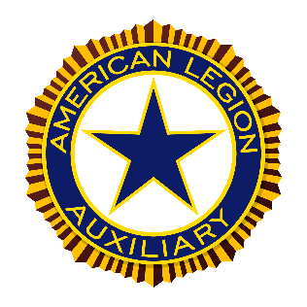

Jane Benzel Department Poppy Chairman
Purpose: The purpose of the Poppy Committee is to educate ALA membership and the public on the significance of the poppy and the program’s financial benefit for veterans, military, and their families. Standing Rules #6, National Committees – Mission Outreach
Key Program Statements:
- Promote the Poppy Program and increase revenue.
- Educate your community on the meaning and the history of the poppy.
- Celebrate National Poppy Day.
- Increase the number of poppy makers in your community.
The National website is a great place to find ideas to help you grow your poppy program. Go to alaforveterans.org. After you have logged in, go to the committees drip down and click on Poppy. There are tons of ideas, patterns for poppies, recipe, and more. ALA Committee Facebook Poppy group is also a great place to discuss get new ideas or share about your Unit poppy activities.
All forms may be found on the South Dakota ALA we http://sdlegionaux.org
Dates to remember:
Poppy posters must be to Department Poppy Chairman by May 15. Please note, there is a cover sheet that needs to be filled out this year to attach to the posters. Send to: Jane Benzel 27949 Horse Camp Rd. Hot Springs, SD 57747
Little Miss Poppy entries must be electronically sent in to National by 5:00est June 1. The cover sheet must be attached. Please cc a copy to me also, or if you need help, let me know.

