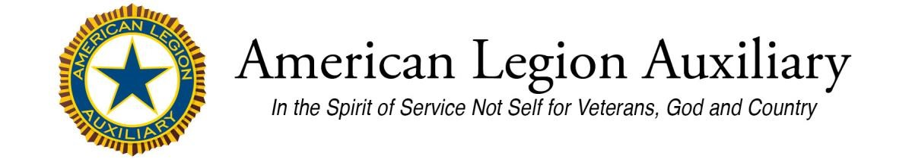
Approval Request – American Legion Auxiliary
Emblem Use
The American Legion owns the names and trademarks of the American Legion Auxiliary. The American Legion Auxiliary is entrusted by The American Legion with protecting the name and official marks of the organization. Use of the emblem must be approved by the ALA National Secretary for printing. If approval is granted it is a one-time, limited use. The following information must be completed in full and submitted to your department secretary.
Requesting Member Name & Unit & Email:
Manufacturer/Vendor Name
Vendor Address:

City: Zip
Vendor Contact Email:

Type of Product(s)
Intended use
Exact Quantity of Item(s) to be Ordered*:
*Ordering new quantities requires a new authorization.
Please include in your email a sample, photo, link to your website or vendor mark-up of the American Legion Auxiliary emblem use.
Department Secretary Signature State Date
Department Secretary: submit completed form to emblem@ALAforVeterans.org

